  
**How to update your address using Bronco Web**

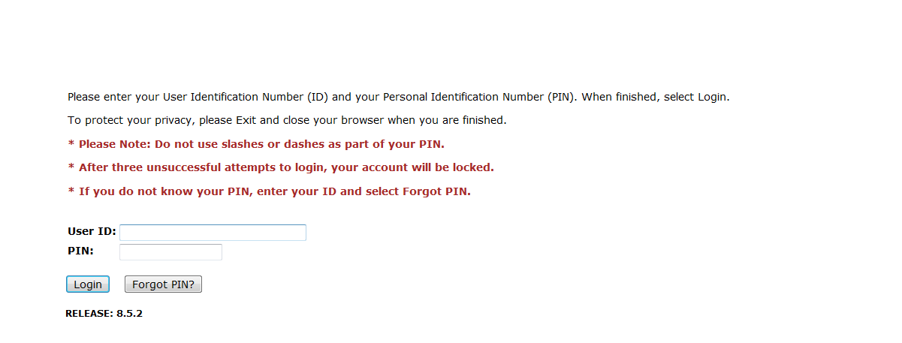

1. **Sign in to** [**Bronco Web**](https://ssb.delhi.edu/pls/prod/twbkwbis.P_WWWLogin) **using your SUNY Delhi 800# and PIN number**

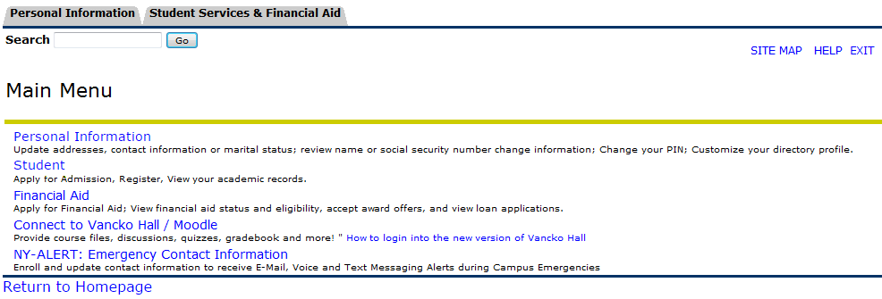

1. **Locate and Click on '*Personal Information*'**

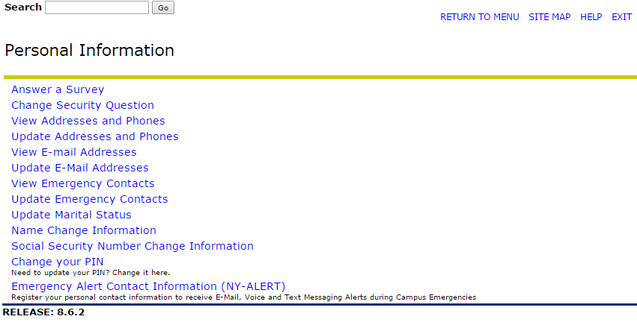

1. **Locate and Click on '*Update Addresses and Phones*'**

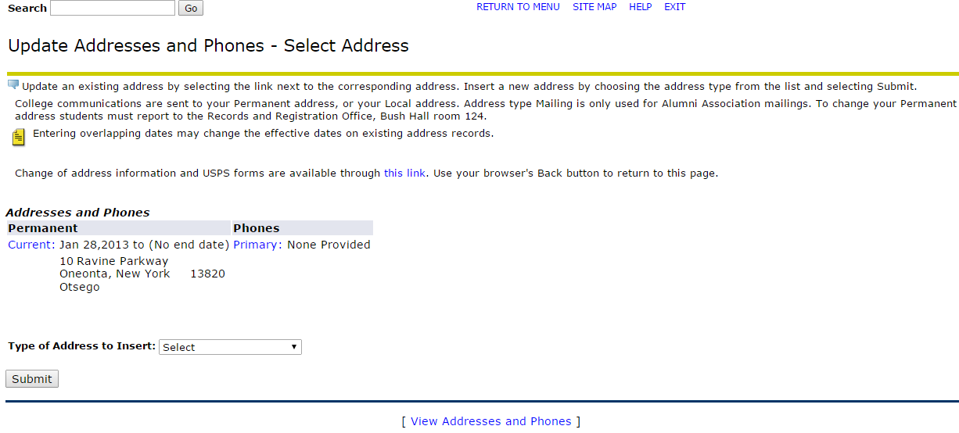

1. **Locate the address you want to update and Click on** **'*Current*'**

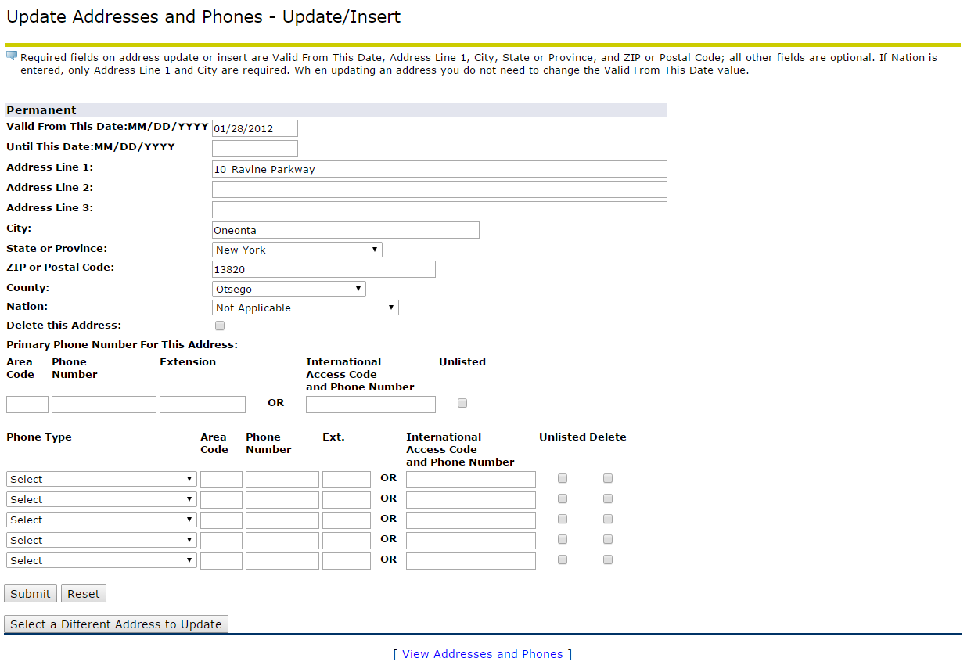

1. **Click on '*Submit***'
2. **Update these Fields**

* Once you have successfully updated your address you will see the changes instantaneously.
* If you have a hold on your account due to a missing address: when you update your permanent or local address your hold will be lifted within 4-5 business days.
* If you have any questions feel free to contact us at (607) 746-4560