# C:\Users\williapd\Downloads\logos_marketing_professionals\Logos for Marketing Professionals\LOGO\Official-Logo_process.gif

**How to Register for Classes**

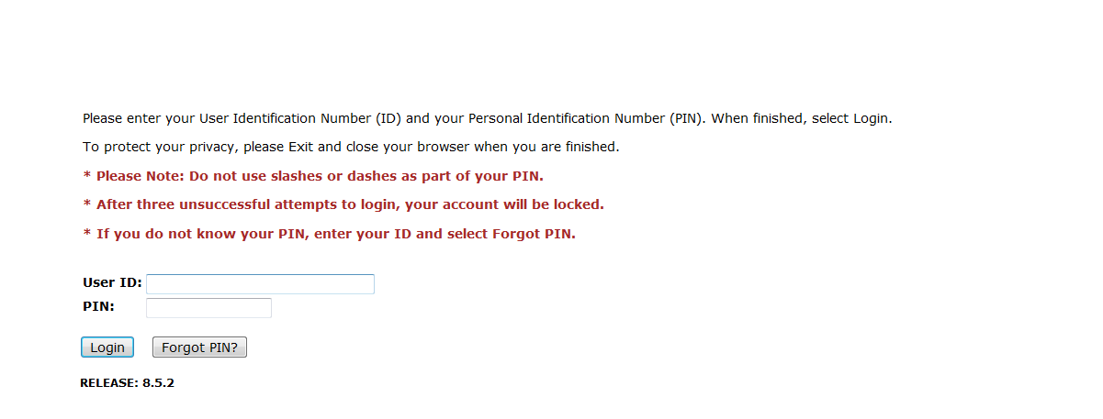**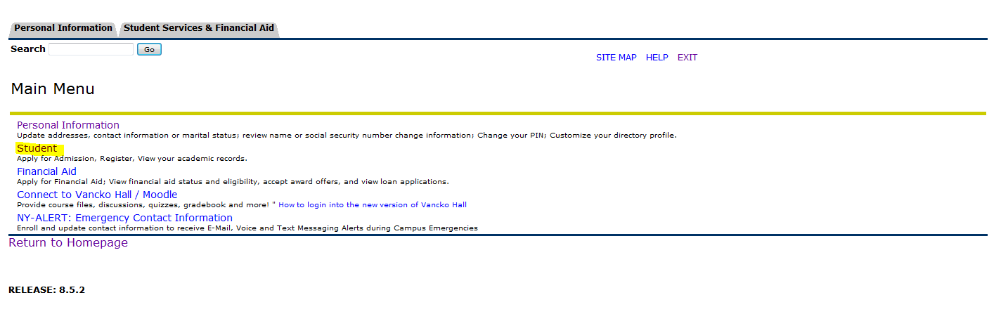**

1. **Click on '*Student*'**
2. **Sign in to** [**Bronco Web**](https://ssb.delhi.edu/pls/prod/twbkwbis.P_WWWLogin) **using your SUNY Delhi 800# and PIN number**

**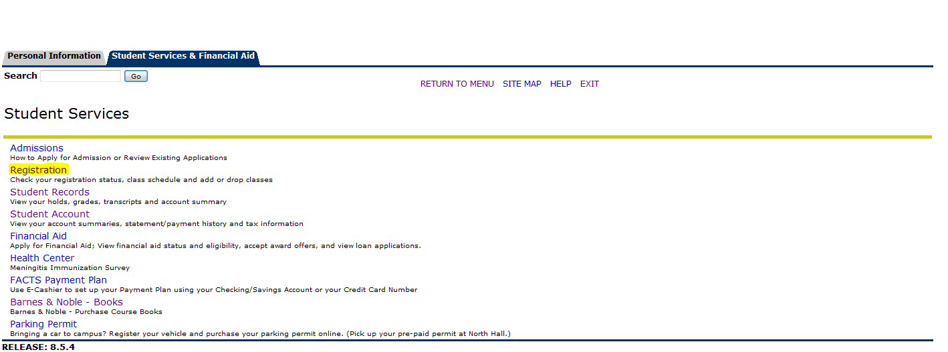**

1. **Click on '*Registration*'**

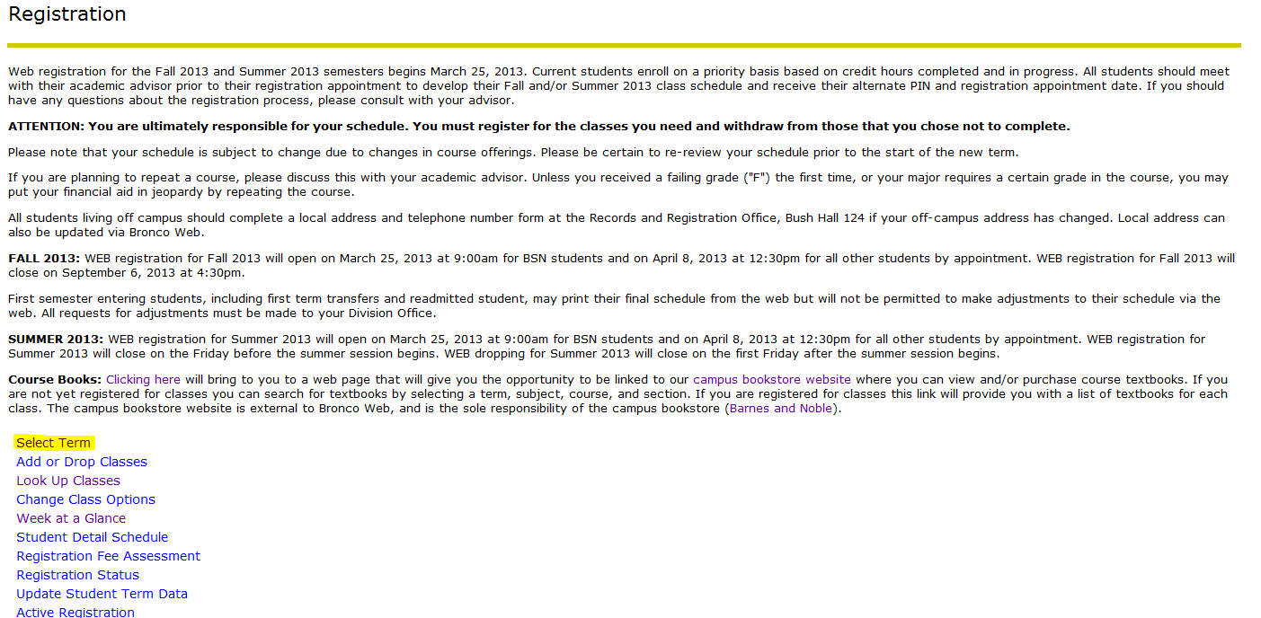

1. **Click on '*Select Term*'**

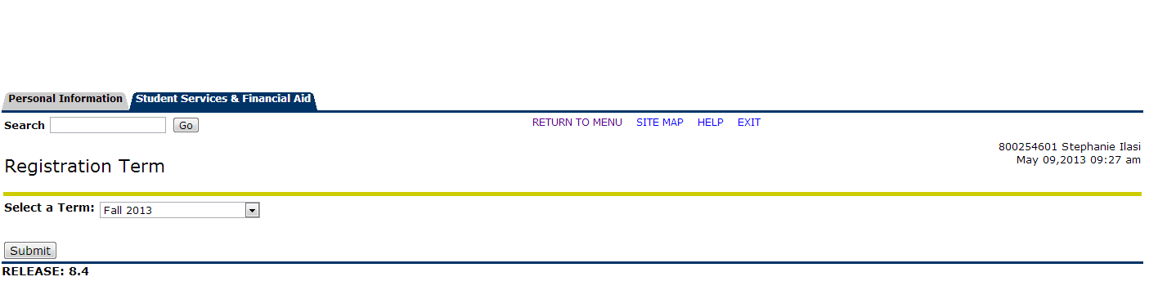

1. **Select a Term**
2. **Click on '*Submit*'**

**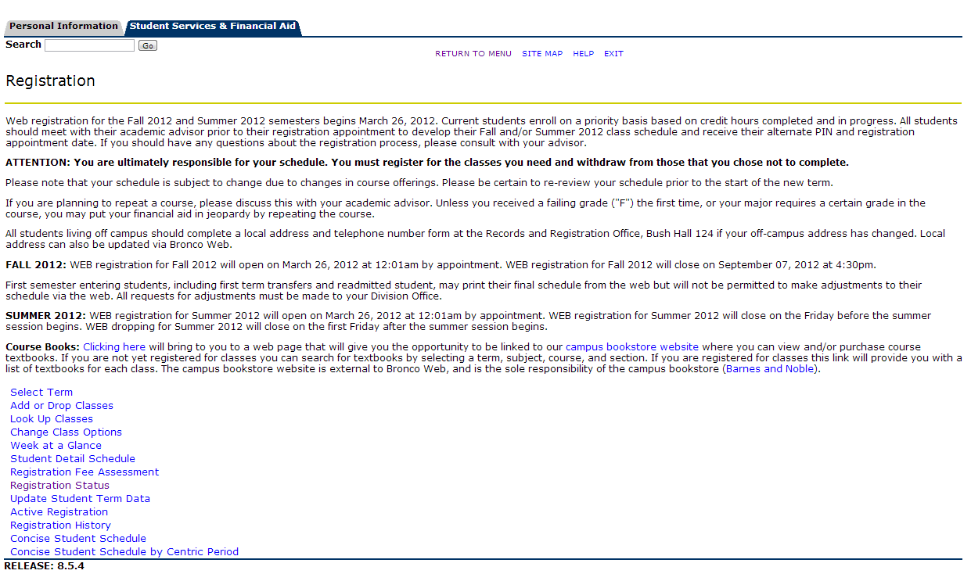**

1. **Click on '*Registration Status*'**

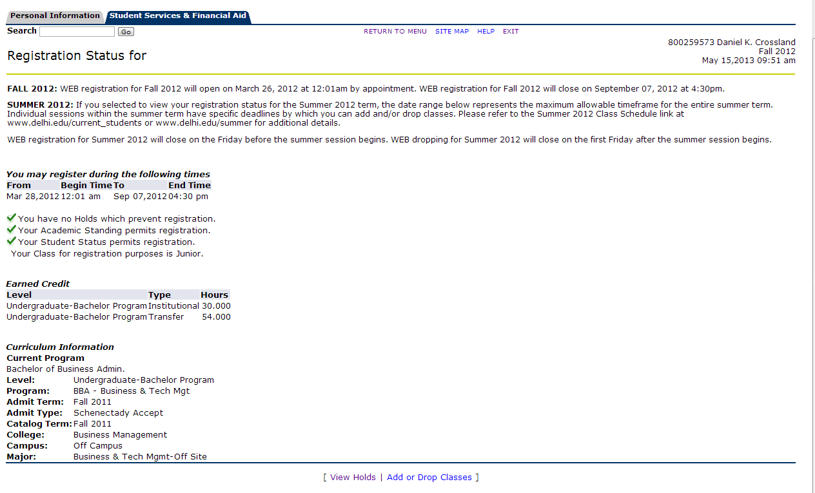

1. **Click on '*View Holds*' if your status is not OK. You will need to speak with the originator of the hold before you can register**
2. **If your Status is Ok, Click on '*Add or Drop Classes*'**

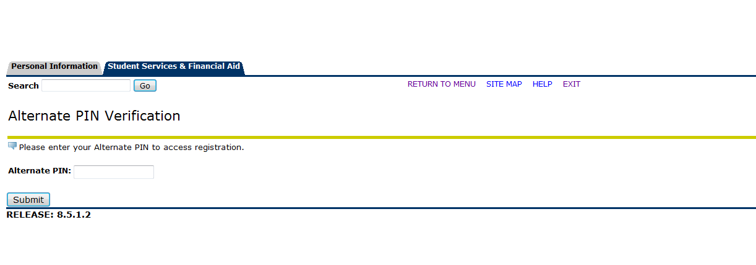

**11.Click on '*Submit*'**

1. **Enter your Alternative Pin (distributed by your adviser)**

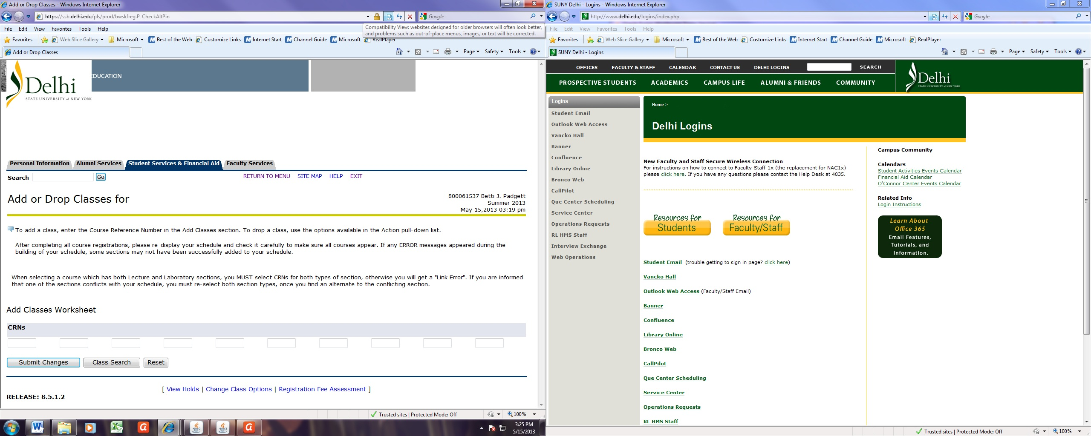

1. **Click on '*Submit Changes*'. This will conclude the process *OR* let you know if you made any errors.**

**If you don’t know the CRN of a class, Click on '*Class Search*'**

1. **Add the 5 digit CRNs into these field boxes**
2. **After you have added your classes, you may return to the menu and review your schedule by selecting *'Student* *Detail Schedule*'.**

* **If changes need to be made then select *'Add or Drop Classes*'**
* **If your schedule is OK, then select *'Week at a Glance*' for a print friendly view**
* **NOTE: Your schedule is subject to change due to changes in course offerings**

**Your Final Schedule will be available on the WEB after 5:00pm on the Thursday before classes begin**