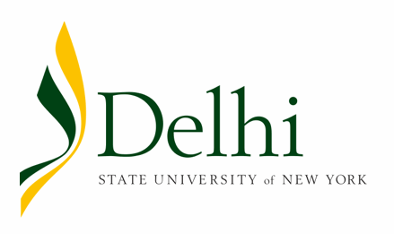
Grant Pre-Submission Authorization
Project Development Concept Form
Please submit 6-8 weeks prior to submission
deadline of the funding agency

- Name of Applicant:
  - Department and Contact Info:

- Please Check One:

  - SUNY Delhi will be the direct recipient

  - SUNY Delhi is a sub-recipient

- If a sub-recipient, please provide the name of agency or institution that we will be contracting with:

_________________________________________________________________________
- Name of the funding entity you are approaching or the names of possible funding sources you would like to approach:
- Amount of request:
- Indicate any cost share or matching requirement amount and if cash or in-kind is required. (Please Note: all cost share requirements must be approved by the Grants Office prior to submission to the leadership team and to the funder.)
- Proposal Due Date:
- Letter of Intent Due Date (if applicable):
- Brief Synopsis of the Program or Project Idea or Need

- Does the Project/Program have the following: If so, please explain:

  - Collaboration:

  - Opportunities for Applied Learning:

  - Innovative Aspects:

  - DEI aspects:

  - Is anyone else operating a similar program/ project and if so, how is this different or unique?

- Summary of Needed Resources
Outline of Budget needs in terms of Staffing, Equipment or Other Expenses (attach separate spreadsheet if needed.)

- Outline any additional funding resources you have cultivated, i.e. private donors in the wings etc.

- How does the Program relate to SUNY Delhi’s mission and the themes within its strategic plan.
https://www.delhi.edu/about/president-office/strategic-plan/

- KEYWORDS- Please provide keywords that can describe your project in a number of ways.
Approvals:
Signature and Date of Approval:
VP/Dean and/or Chair/ Supervisor_________________________________________

Signature and Date of Approval:
Director of the Grants Office __________________________________________

